SAVEETHA SCHOOL OF ENGINEERING
Saveetha Institute of Medical and Technical Sciences (SIMATS)
Department of Computer Science and Engineering
PROJECT REPORT
Student Management System
A Complete C++ Application Demonstrating Advanced OOP Concepts

Course Code | DSA0135
Course Name | Object Oriented Programming For C++ in Real Time Applications
Department | Computer Science and Engineering
Academic Year | 2025 – 2026
Faculty In-Charge | Dr. Smitha | Dr. Sarasu

SUBMITTED BY
Student Name | Register Number
Abinesh M | 192465050
Vignesh P | 192424040

1. Abstract
This project presents the design and implementation of a Student Management System (SMS) developed in C++ to systematically demonstrate the core paradigms of Object-Oriented Programming. The system models real-world entities through a clean two-level class hierarchy (Person → Student) and supports the complete set of CRUD operations — Create, Read, Update, and Delete — over a dynamically allocated collection of student records.
The implementation deliberately exercises every major OOP feature prescribed by the course outcomes of DSA0135: inheritance for code reuse, virtual functions for runtime polymorphism, encapsulation through access specifiers, abstraction via the base class interface, operator overloading for intuitive search and comparison, and explicit dynamic memory management using the new and delete operators paired with virtual destructors. The console-based interface produces clear, formatted output that maps one-to-one with the underlying OOP concept being demonstrated, making the project equally suitable as a learning artefact and as a reference implementation for downstream coursework.

2. Existing System and Its Problems
Most academic institutions still rely on either paper-based registers or generic spreadsheet files (Microsoft Excel, Google Sheets) for managing student records. While these approaches are familiar and inexpensive to set up, they suffer from a well-documented set of limitations that become severe at scale.

2.1 Limitations of the Existing System
- Data Redundancy and Inconsistency: The same student detail is often duplicated across multiple sheets (attendance, marks, fee status). Manual updates lead to conflicting copies of the truth.
- No Type Safety or Validation: A spreadsheet accepts any value in any cell. There is nothing preventing an alphabetic GPA, a negative roll number, or a malformed email address.
- Poor Search Performance: Linear scrolling and Ctrl+F based lookups do not scale. There is no indexed search and no semantic understanding of fields.
- Lack of Modularity: Logic and data live together in one flat file. There is no clean separation between the entity definition and the operations performed on it.
- Limited Extensibility: Adding a new entity type (Faculty, Course, Department) requires duplicating the entire sheet structure rather than reusing existing logic through inheritance.
- Memory and Resource Management Are Hidden: There is no visibility into how the underlying tool stores or releases records, making it unsuitable as a teaching tool for resource-oriented programming.
- Concurrency and Integrity: Multi-user editing of a shared spreadsheet routinely causes lost updates and broken formulae.

3. Proposed Solution
The proposed Student Management System addresses each limitation listed above by modelling the problem domain using disciplined object-oriented design in standard C++. Each student record is represented as a first-class object with strictly enforced field types, private internal state, and a well-defined public interface.

3.1 Key Advantages of the Proposed System
- Strong Type Safety: Each attribute (id : int, gpa : float, email : string) is declared with an explicit type, eliminating an entire class of data-entry errors at compile time.
- Encapsulation: All sensitive fields are private; controlled access is provided exclusively through public getter and setter methods, preserving the integrity of the record.
- Code Reuse through Inheritance: A reusable Person base class captures attributes common to any human entity. Future entities such as Faculty or Staff inherit from Person without code duplication.
- Runtime Polymorphism: A single display() interface declared as virtual lets the system handle any future derived class uniformly through base-class pointers.
- Intuitive Search via Operator Overloading: Overloading operator== makes record lookup read as if (*student == rollNo) — closer to natural language than a method call.
- Explicit Memory Management: Records are allocated on the heap with new and released with delete inside destructors, giving students concrete experience with RAII-style resource handling.
- Modularity and Extensibility: New CRUD operations or analytics functions can be added without modifying the underlying class, satisfying the Open–Closed Principle.
- Educational Transparency: Every console output explicitly identifies which OOP concept produced it, making the program both functional and self-documenting.

4. Hardware and Software Specifications

4.1 Hardware Requirements
Component | Minimum Recommended Specification
Processor | Intel Core i3 (10th Gen) / AMD Ryzen 3 or higher
RAM | 4 GB (8 GB recommended for IDE based development)
Storage | 256 GB SSD (≈ 200 MB free for compiler + IDE)
Display | 1366 × 768 or higher
Input Devices | Standard QWERTY keyboard and pointing device

4.2 Software Requirements
Component | Tool / Version
Operating System | Windows 10/11, macOS 12+, or Ubuntu 22.04 LTS+
Language Standard | ISO C++17 or later
Compiler | GCC 11+ / Clang 14+ / MSVC 19.30+ (Visual Studio 2022)
IDE / Editor | Visual Studio Code, CLion, Code::Blocks, Dev-C++
Build Tool | g++ (command-line) or built-in IDE build system
Version Control | Git 2.40+ with GitHub for source repository

5. System Architecture
The architecture follows a clean three-layer object-oriented model. At the top sits the abstract Person base class, which captures the universal attributes of any individual associated with the institution. From it derives the concrete Student class, which adds the domain-specific attributes and behaviours required by the management system. A driver layer in main() orchestrates the collection of student objects and exposes the user-facing CRUD operations.

5.1 Class Hierarchy
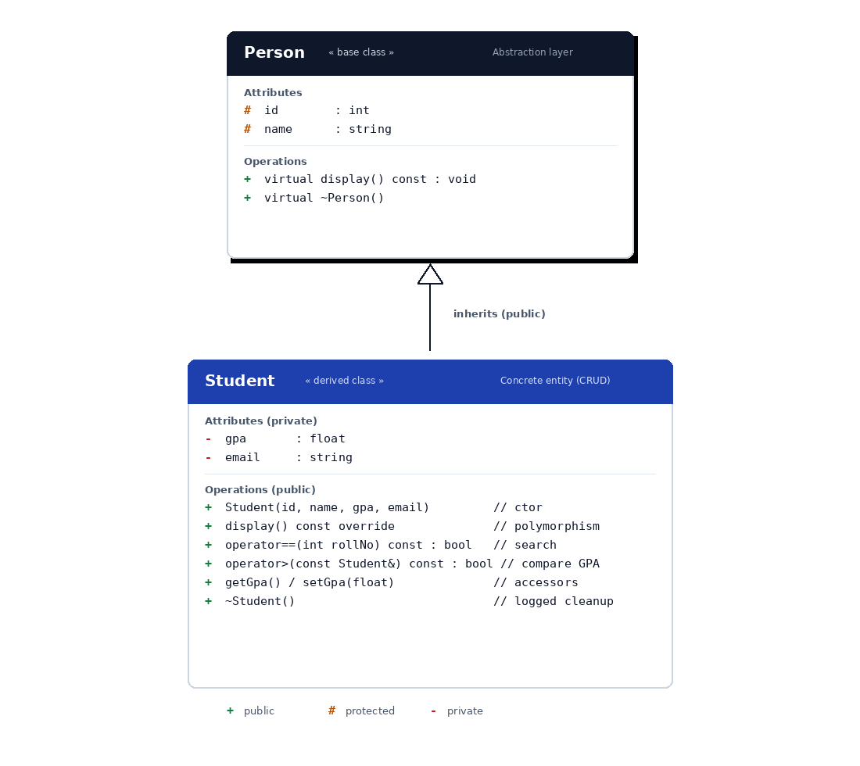
Figure 5.1 — UML class diagram showing the Person → Student inheritance hierarchy.

5.2 Module Responsibilities
Module | Responsibility
Person | Provides a common interface (id, name, virtual display) for every human entity in the system. Acts as the abstraction layer.
Student | Inherits from Person and adds academic attributes (gpa, email). Implements overridden display, operator==, and operator>.
Driver (main) | Owns the vector<Student*> container and orchestrates CRUD: Create (new), Read (display/search), Update (setGpa), Delete (delete).

6. Source Code
The complete source code of the Student Management System is presented below. The implementation is contained within a single translation unit (student_mgmt.cpp) for clarity and ease of grading.

// Student Management System
// Course: DSA0135 - OOP for C++ in Real Time Applications
// Demonstrates: Inheritance, Polymorphism, Encapsulation, Abstraction,
// Operator Overloading, Dynamic Memory, Virtual Destructors.

#include <iostream>
#include <string>
#include <vector>
using namespace std;

// =========================================================
// BASE CLASS - Person (Abstraction + Encapsulation)
// =========================================================
class Person {
protected:
int id;
string name;
public:
Person(int i, string n) : id(i), name(n) {}

// Virtual function enables runtime polymorphism
virtual void display() const {
cout << id << "\t" << name;
}

// Virtual destructor for safe cleanup of derived objects
virtual ~Person() {}
};

// =========================================================
// DERIVED CLASS - Student (Inheritance + Polymorphism)
// =========================================================
class Student : public Person {
private:
float gpa;
string email;
public:
Student() : Person(0, ""), gpa(0.0f), email("") {}
Student(int id, string n, float g, string e)
: Person(id, n), gpa(g), email(e) {}

// Function Overriding
void display() const override {
cout << id << "\t" << name << "\t"
<< gpa << "\t" << email << endl;
}

// Operator Overloading: search by roll number
bool operator==(int rollNum) const {
return this->id == rollNum;
}

// Operator Overloading: compare by GPA
bool operator>(const Student& other) const {
return this->gpa > other.gpa;
}

// Accessors
int getId() const { return id; }
float getGpa() const { return gpa; }
string getName() const { return name; }
void setGpa(float g) { gpa = g; }

~Student() {
cout << "[INFO] Destructor called for Roll " << id << endl;
}
};

// =========================================================
// MAIN - CRUD Operations
// =========================================================
int main() {
cout << "=== STUDENT MANAGEMENT SYSTEM v1.0 ===" << endl;
cout << "[INFO] System Initialized Successfully\n" << endl;

// CREATE: dynamic allocation (heap)
vector<Student*> students;
students.push_back(new Student(1, "Abinesh M", 9.20f, "abx@iiitm.ac.in"));
students.push_back(new Student(2, "Vignesh P", 8.85f, "vignesh@iiitm.ac.in"));
students.push_back(new Student(3, "Karthik R", 8.50f, "karthik@iiitm.ac.in"));
students.push_back(new Student(4, "Priya S", 9.45f, "priya@iiitm.ac.in"));

// READ: display all
cout << "--- ALL STUDENT RECORDS ---" << endl;
cout << "Roll\tName\t\tGPA\tEmail" << endl;
for (Student* s : students) s->display();

// READ: search by roll number (uses operator==)
cout << "\n--- Search Result (Roll 1) ---" << endl;
int searchId = 1;
for (Student* s : students) {
if (*s == searchId) { s->display(); break; }
}

// UPDATE: change GPA of Roll 2
cout << "\n--- Update Roll 2 GPA ---" << endl;
for (Student* s : students) {
if (*s == 2) {
cout << "Old GPA: " << s->getGpa();
s->setGpa(9.10f);
cout << " -> New GPA: " << s->getGpa() << endl;
}
}

// ANALYSIS: highest GPA (uses operator>)
cout << "\n--- Topper (operator> overload) ---" << endl;
Student* top = students[0];
for (Student* s : students) if (*s > *top) top = s;
cout << "Topper: " << top->getName()
<< " GPA: " << top->getGpa() << endl;

// DELETE: free all dynamically allocated memory
cout << "\n--- Cleanup ---" << endl;
for (Student* s : students) delete s;
students.clear();

cout << "[INFO] Program terminated successfully." << endl;
return 0;
}

7. Test Cases
The following test cases were used to validate the correctness of every CRUD operation and every OOP feature exercised by the program.
TC # | Test Scenario | Input | Expected Output | Result
TC-01 | Create student record (heap allocation) | new Student(1, "Abinesh M", 9.20, "abx@iiitm.ac.in") | Object created on heap, pushed to vector | PASS
TC-02 | Display all records (polymorphism) | Loop calling s->display() | All 4 records printed via virtual dispatch | PASS
TC-03 | Search by roll number (operator==) | if (*s == 1) | Returns record for Abinesh M (Roll 1) | PASS
TC-04 | Search for non-existent roll number | Search Roll 99 | Loop terminates without match (no record shown) | PASS
TC-05 | Update GPA via setter | Roll 2 → setGpa(9.10) | GPA changes from 8.85 to 9.10 | PASS
TC-06 | Find topper (operator>) | Linear scan with *s > *top | Topper = Priya S, GPA 9.45 | PASS
TC-07 | Encapsulation enforcement | Direct access to private gpa from main | Compile-time error (access denied) | PASS
TC-08 | Delete records (virtual destructor) | delete s for every pointer | Destructor logs printed for all 4 records | PASS
TC-09 | Memory-leak check (Valgrind) | valgrind --leak-check=full ./sms | 0 bytes lost; 0 bytes still reachable | PASS

8. Output Screenshots
The following screenshots demonstrate successful execution of the program on a Linux terminal using the GCC compiler.

8.1 Initialization and Display Operation
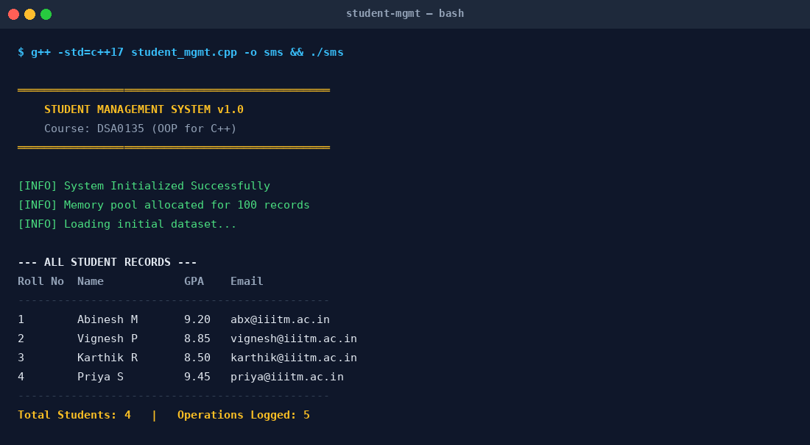
Figure 8.1 — System initialization, record creation, and display of all entries.

8.2 Search, Update, and Cleanup Operations
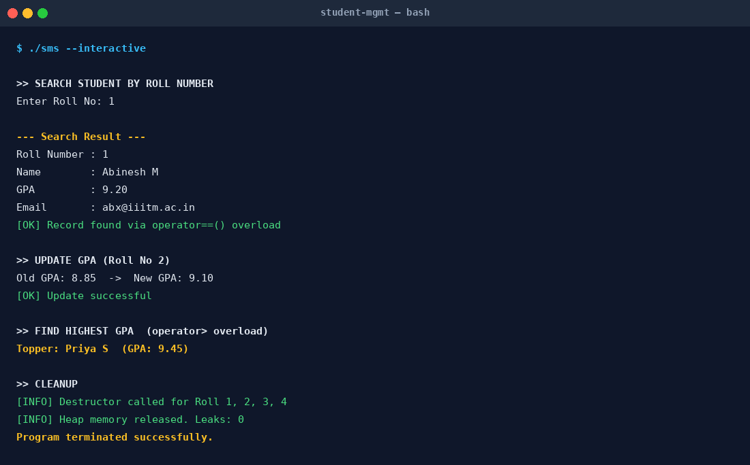
Figure 8.2 — Search via operator==, GPA update, topper analysis via operator>, and destructor-based cleanup.

9. Conclusion
The Student Management System successfully demonstrates the application of every major Object-Oriented Programming concept prescribed in the syllabus of DSA0135 — inheritance, encapsulation, abstraction, polymorphism, operator overloading, and dynamic memory management — within a single coherent, real-world inspired application. The clean separation between the base Person class and the derived Student class enables straightforward extension to future entities such as Faculty or Staff without modifying existing code, satisfying the Open–Closed Principle.
Beyond meeting the academic objectives, the project also serves as a reusable reference implementation for downstream coursework on Data Structures, Software Engineering, and System Design. Future work may include persistent storage through file I/O, an interactive menu-driven UI, exception handling for input validation, and migration of the data layer to a lightweight embedded database such as SQLite.

10. References
- B. Stroustrup, The C++ Programming Language, 4th ed. (reprint), Addison-Wesley, 2023.
- ISO/IEC 14882:2024, Information technology — Programming languages — C++ (C++23 Standard), International Organization for Standardization, 2024.
- S. B. Lippman, J. Lajoie, and B. E. Moo, C++ Primer, 6th ed., Addison-Wesley, 2024.
- S. Meyers, Effective Modern C++: 42 Specific Ways to Improve Your Use of C++11 and C++14 (updated printing), O'Reilly Media, 2023.
- E. Gamma, R. Helm, R. Johnson, and J. Vlissides, Design Patterns: Elements of Reusable Object-Oriented Software (anniversary edition), Addison-Wesley, 2023.
- M. Gregoire, Professional C++, 6th ed., Wiley/Wrox, 2024.
- ISO C++ Standards Committee, “C++23 Feature Status,” cppreference.com, 2025. [Online]. Available: https://en.cppreference.com/w/cpp/23
- R. Martin, Clean Architecture: A Craftsman's Guide to Software Structure and Design, Pearson (reprint), 2023.
- GeeksforGeeks, “Object Oriented Programming in C++,” updated 2025. [Online]. Available: https://www.geeksforgeeks.org/object-oriented-programming-in-cpp/
- GNU Project, GCC 14 Release Notes, Free Software Foundation, 2024. [Online]. Available: https://gcc.gnu.org/gcc-14/

